YOUR AMERICAN GUT SAMPLE

What’s in your oral sample?
Taxonomy | Sample | Population | Fold
Genus Chryseobacterium | 24.69% | 0.73% | 34x
Genus Rothia | 28.88% | 11.35% | 3x
Genus Comamonas | 0.61% | 0.04% | 14x
Genus Enterococcus | 0.13% | 0.04% | 3x
Taxonomy | Sample
Genus Rothia | 28.9%
Genus Chryseobacterium | 24.7%
Genus Streptococcus | 16.7%
Genus Neisseria | 6.7%
Class Actinobacteria Class Flavobacteriia
Your most abundant microbes: Your most enriched microbes:
Class Bacilli
Class Gammaproteobacteria
Class Betaproteobacteria
Class Clostridia
Class Coriobacteriia
Class Sphingobacteriia
Class Bacteroidia
Class Alphaproteobacteria
Class Erysipelotrichi There were no rare or unique taxa found in your sample.
Other This sample was registered on August 2, 2014 at 11:35.
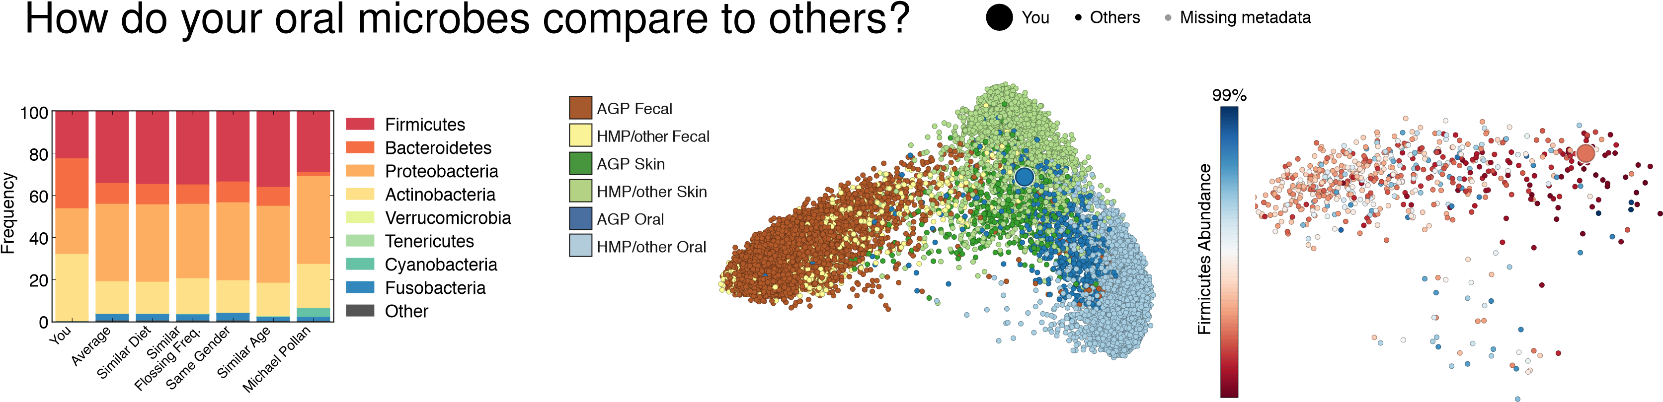
0%
Different Subpopulations Different Body Sites The American Gut Population

